MEDIA RELEASE

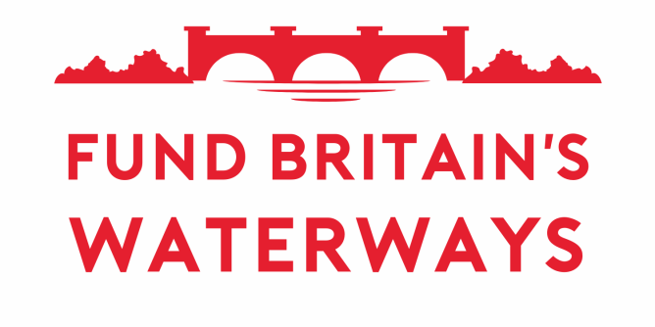

For immediate release
Date: 23 April 2024

Closing waterways is our last resort says Canal & River Trust
An open and frank discussion took place this month between representatives from the Fund Britain’s Waterways (FBW) coalition and senior representatives of the Canal & River Trust as the Trust answered questions from FBW about its current strategy, future plans and the value for money it provides in managing its 2000-mile inland waterway network.
During the meeting held on 10th April at Hatton Locks, Warwickshire, the Chief Executive of the Canal & River Trust, Richard Parry, said that despite the growing funding gap created by diminishing government grant, high inflation and the need to mitigate the impacts of climate change, the Trust had no current plans to close any of its waterways to navigation. However, he warned that the government funding announced for the period 2027 – 2037 will be insufficient to safeguard the future of the waterways. This is why the Trust is calling for that planned grant to be reviewed. In the meantime, the Trust said it was making every effort to reduce the increasing funding gap by maximising its income from fundraising and other sources, including its property endowment.
FBW welcomed the fact that the Trust saw canal closures as a last resort. The FBW campaign will continue to highlight the public value provided by Britain’s entire network of inland waterways, in terms of both economic and social benefits, and press the government to intervene with a fairer funding settlement for all waterways before a tipping point is reached when closures could become unavoidable.
Les Etheridge, Chair of FBW, said:
“It was reassuring to hear that Canal & River Trust is not currently planning to close any waterways to navigation. As the government discovered in the 1960s, closing waterways does not save money as ongoing maintenance is required for safety purposes yet most of the economic, environmental and wellbeing benefits are lost. We need the next government to understand this fact and recognise the substantial value our canals and rivers currently provide.”

ENDS

Notes to the Editor
About Fund Britain’s Waterways (FBW): FBW brings together a wide range of organisations with the sole purpose of campaigning collectively for an increase in government funding of Britain’s inland waterways to avert their decline, and to promote awareness of the huge economic, environmental and social well-being value they provide. Established in June 2023, it already has more than 125 members representing hundreds of thousands of users and supporters of inland waterways.
The meeting with the Canal & River Trust was attended by the following representatives from FBW:
- the Association of Waterways Cruising Clubs
- British Marine
- the Inland Waterways Association
- the National Association of Boat Owners
- the Royal Yachting Association
FBW’s wider membership were able to watch a livestream of the event and a summary of the discussion will be published on FBW’s website shortly.

FBW plans for 2024 include similar discussions with other inland navigation authorities as well as an important weekend of action over the May Day Bank Holiday weekend (4th to 6th May 2024) to highlight the impact of insufficient funding for Britain’s 5,000 miles of inland waterways.
The weekend of action is planned to take place across the country on waterways managed by different navigation authorities. It will coincide with IWA’s annual Canalway Cavalcade at Little Venice in London, which this year will be themed on Fund Britain’s Waterways.
Boaters attending Cavalcade will be joining a Campaign Cruise past the Houses of Parliament on Wednesday 8th May, as the culmination of the weekend of action. Parliamentarians have been invited to view the event from a private charter boat and express their support for the continued maintenance of the waterways to enable them to keep on delivering economic, health, environmental and well-being benefits.

For further information:
Email Fund Britain’s Waterways at info@fundbritainswaterways.org.uk

